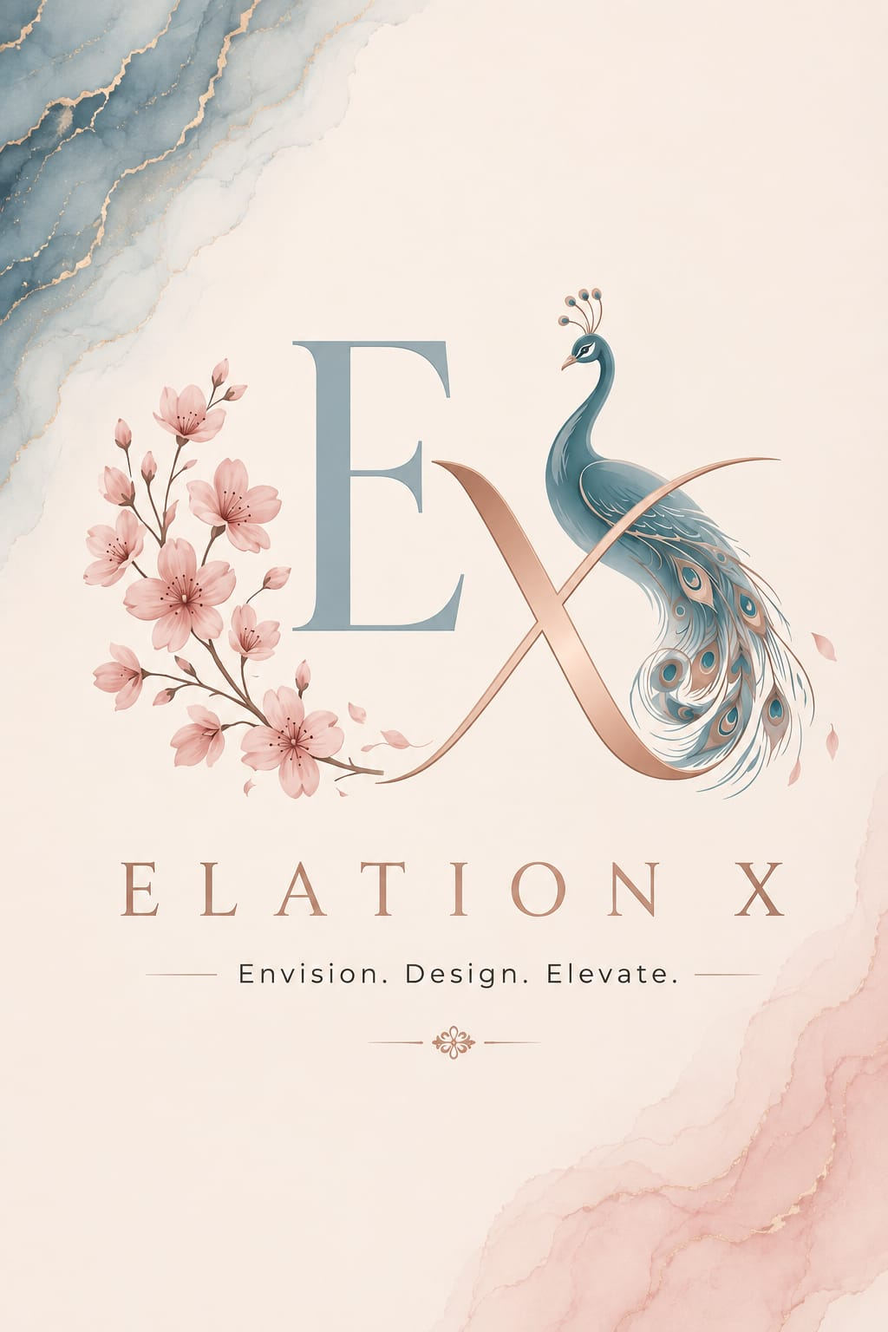

Timeline

Phase 1: Web Application Development
- Expected Start: Sunday, August 30
- Estimated Duration: Up to 2 weeks
- Target Completion: September 13 - September 15

Each AR visualization set is estimated to require approximately 10–15 days of development, with all three sets expected to be completed within approximately 1–1.5 months.

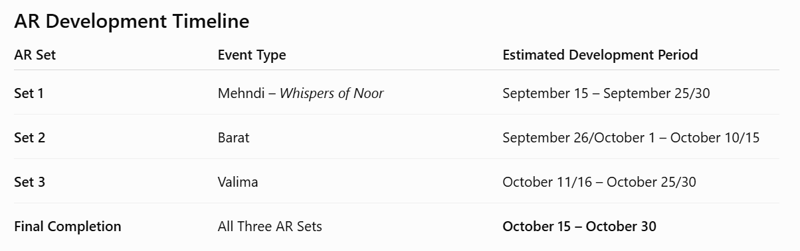

WebApp
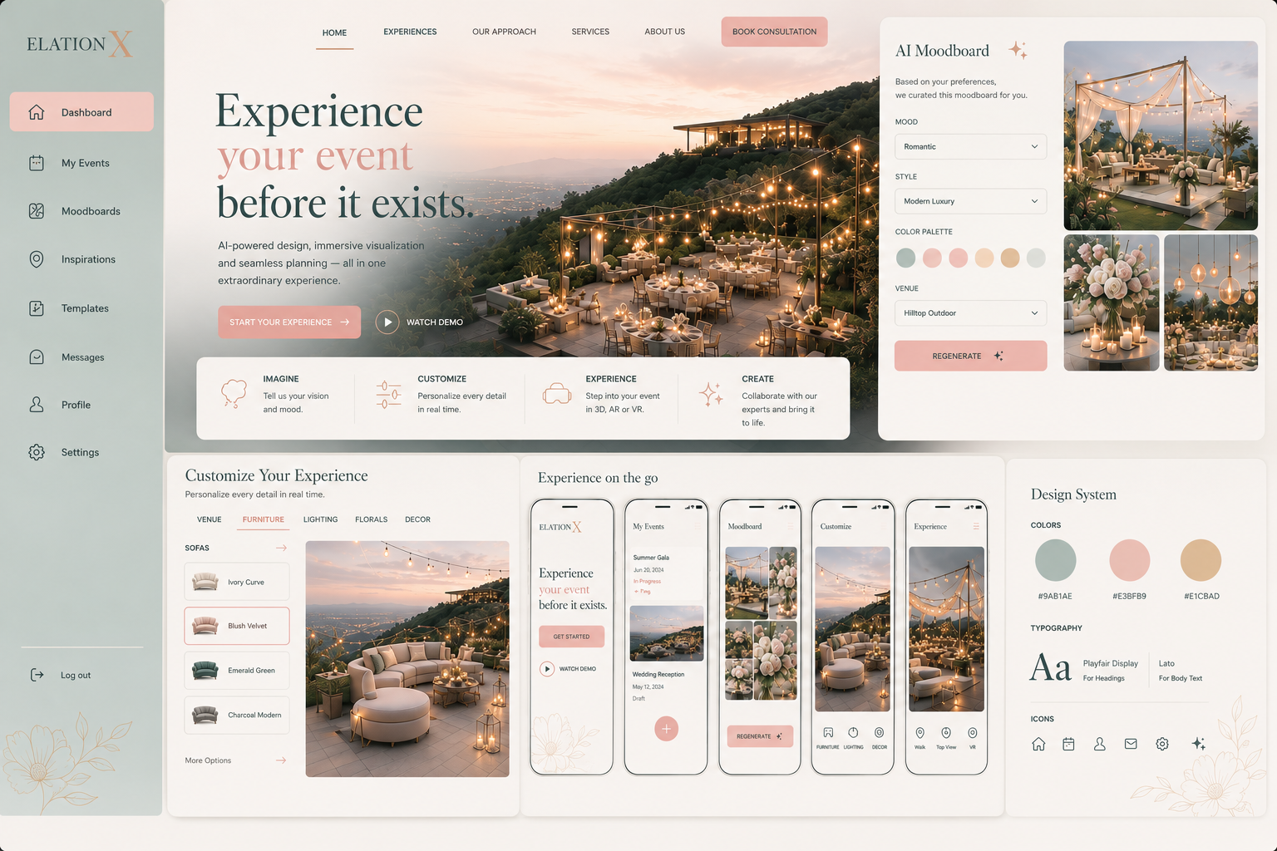
Theme of webapp:
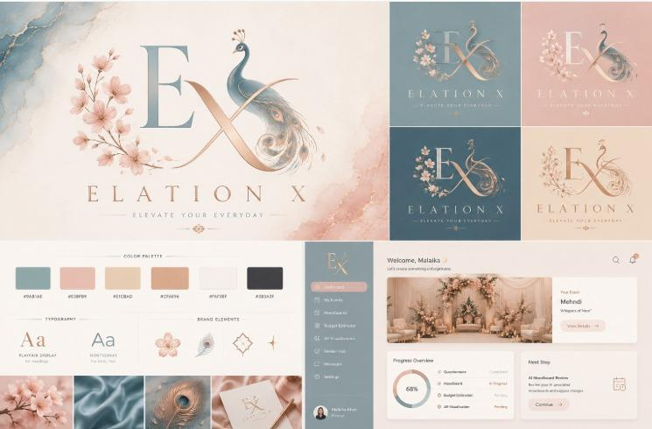

Core Modules We Need Built
Module | What It Needs To Do | Priority
AI Consultation & Moodboard | Client answers a short guided questionnaire capturing event type, theme preferences, budget, guest count, and preferred style. Based on these inputs, the system uses AI-assisted recommendation logic to analyze and match suitable items from Elation's existing inventory, generating a personalized, inventory-aware moodboard and theme recommendation.  - Questionnaire shared in zip file | Must-have
About us section | Details added in lookbook pdf 1st 3 pages
Smart Budget Estimator | During the guided questionnaire, the client enters their intended event budget as a numerical value. Based on the selected theme, guest count, preferences, and Elation's existing inventory and pricing, the system generates an initial estimated cost for the recommended setup. Clients can then customize the setup by adding optional inventory-based add-ons or removing selected elements, with the estimated total updating dynamically in real time. A colour-coded indicator will show whether the updated configuration is on budget (green), under budget (yellow), or over budget (red). | Must-have
Admin/Consultant View/ Dashboard | Backend dashboard for the Elation team to manage client access and view inquiries, generated concepts, consultation progress, follow-ups, and analytics on client preferences, popular themes, budget ranges, and consultation trends.
Inspirations of moodboards | The Moodboards section will include an Inspiration Gallery showcasing a curated selection of ready-made event themes and design concepts. This feature will assist clients who may be uncertain about their desired aesthetic by allowing them to browse and explore pre-designed concepts. Upon selecting an inspiration, the client can directly adopt the showcased concept for their event or use it as a starting point for further customization, with the selected design elements and inventory carried forward into their personalized moodboard and budget estimation.  Inspirations will also be shared.
Dark Mode
Admin & Client Account | The platform will be restricted from general public access. Access will be granted by the Elation X team through the Admin Dashboard, where administrators can create temporary accounts for clients undergoing consultation. These accounts will provide clients with access to their personalized event concepts, moodboards, budget estimates, and customization features. Each account will have an automatically assigned expiry period, after which access will be disabled. Through the Admin Dashboard, the Elation X team will also be able to manually adjust or extend a client's access period when required. | Must have

Smart budget estimator:

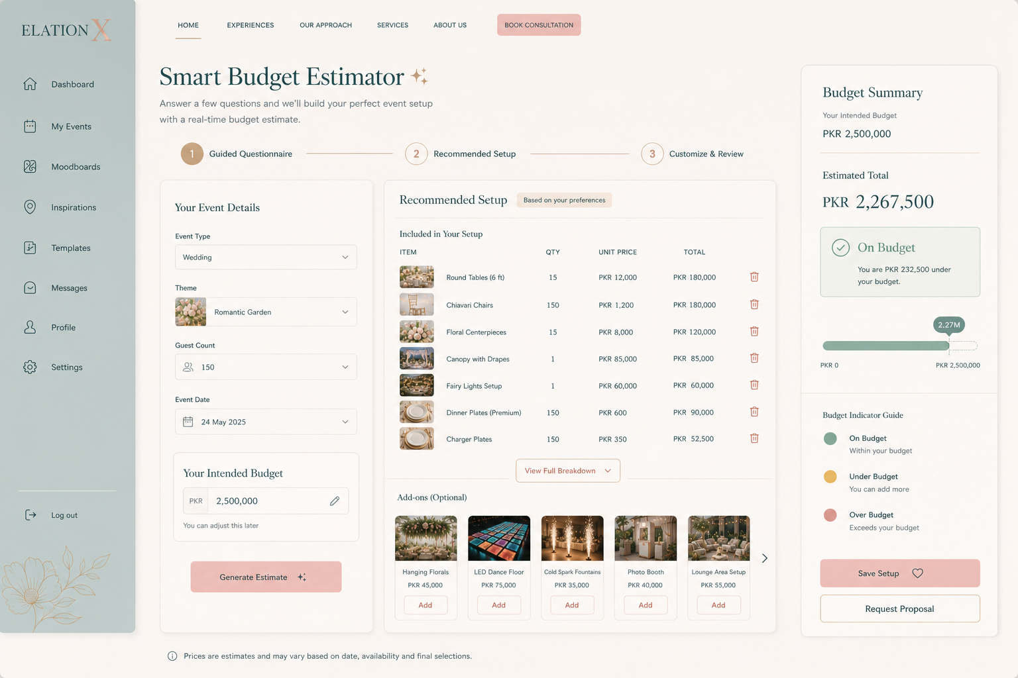

Inventory-Aware Recommendations | Recommendations should pull from Elation by FMH's actual inventory rather than generic suggestions. The inventory data/database, including the available items and relevant details, will be provided by our team for integration into the system | Should-have

AR Event Visualization – Set 1: Whispers of Noor
Clients will use Meta Quest 3 to walk through the actual event venue while viewing augmented reality (AR) visualizations overlaid onto their real-world surroundings. This experience is not Virtual Reality (VR); the physical venue and background will remain visible through the headset's passthrough capabilities, while selected digital 3D event elements and décor will be placed within the real environment.
For the AR experience, the team will provide the required 3D models, which are being generated using Tripo AI and Meshy AI.

Set 1: Baraat / nikkah
The first AR visualization set will be based on the baraat / nikkah event concept. The development team will be provided with:
- The finalized theme and visual concept
- The floor plan/layout
- An aerial view of the proposed setup
- Relevant 3D models and event assets
These materials will serve as the reference for placing and visualizing the AR décor and event elements within the actual venue.

Set 2: Walima/Baraat Moodboard
- The finalized theme and visual concept
- The floor plan/layout
- An aerial view of the proposed setup
- Relevant 3D models and event assets

Set 3: Mehndi
- The finalized theme and visual concept
- The floor plan/layout
- An aerial view of the proposed setup
- Relevant 3D models and event assets

Inspirations
Images added below
Remaining details included in pdf attached in zip file

